CS 340 README Template

About the Project/Project Title
This project is where I built the create and read parts of a CRUD Python module for the Austin Animal Center (AAC) database. The module connects to MongoDB and lets me add new animal records and look up existing ones using PyMongo. It’s basically the first piece of the database functionality I’ll use later in the course.

Motivation
The main reason for building this module is to have reusable database code that I can plug into the dashboard project later on. Getting the create and read functions working now sets me up for the full CRUD setup I’ll finish in Project One. This assignment is basically laying the groundwork for everything that comes next.

Getting Started
This is an example of how you may give instructions on setting up your project locally: “To get a local copy up and running, follow these simple example steps.”

To get started, I first set up the AAC database in Module Three by importing the aac_shelter_outcomes.csv file into MongoDB and creating the aacuser account with read/write permissions. In Module Four, I created the AnimalShelter class and implemented the create() and read() methods using PyMongo.

Installation
For this project, I worked completely inside the Codio environment, which already comes with everything set up for us. I didn’t have to manually install MongoDB or PyMongo myself. Codio includes Python, MongoDB, and the PyMongo driver by default, so I was able to start writing and testing my CRUD module right away in Jupyter Lab.

Tools that I used:
- Codio / Jupyter Lab - where I wrote and tested my module
- Python 3 – used to build the CRUD class
- MongoDB – the AAC database runs inside Codio
- PyMongo – the MongoDB driver that lets Python interact with the database

Usage
Below is an example of how the module works and some of the code used. First, import the class and authenticate using the AAC user account:

from CRUD_Python_Module import AnimalShelter
shelter = AnimalShelter("aacuser", "GreenLantern")

In order to create a new record I used:

test_data = {
"name": "Duke",
"animal_type": "Dog",
"breed": "Labrador Retriever",
"age_upon_outcome": "3 years",
"outcome_type": "Adoption"
}
print("Create result:", shelter.create(test_data))

Code used to read the records:

results = shelter.read({"breed": "Labrador Retriever"})
print(results)

Code Example
def create(self, data):
result = self.collection.insert_one(data)
return True if result.inserted_id else False

def read(self, query):
cursor = self.collection.find(query)
return list(cursor).

My code Explanation:
The create() method inserts a new document into the MongoDB collection and returns True if successful. The read() method searches the collection using a query and returns all matching documents as a list. These methods combined together provide basic functions for adding and retrieving animal records.

Tests

print("Create result:", shelter.create(test_data))
results = shelter.read({"breed": "Labrador Retriever"})
print(results)

Test Explanation:
The first line tests my create() method by inserting the test record for “Duke.” If the insert works, it prints True, which tells me the create function is doing what it’s supposed to.
The second line tests my read() method by looking up all animals with the breed “Labrador Retriever.” When I print the results, I can see the records that match the query, including the one I just added. This confirms that the read function is returning data correctly and that my module is talking to MongoDB the way it should.

Screenshots

This screenshot shows my CRUD_Python_Module.py file where I built the AnimalShelter class. It includes the connection setup for MongoDB and the create and read methods I implemented for this assignment. This is the module that my Jupyter Notebook imports and uses during testing. 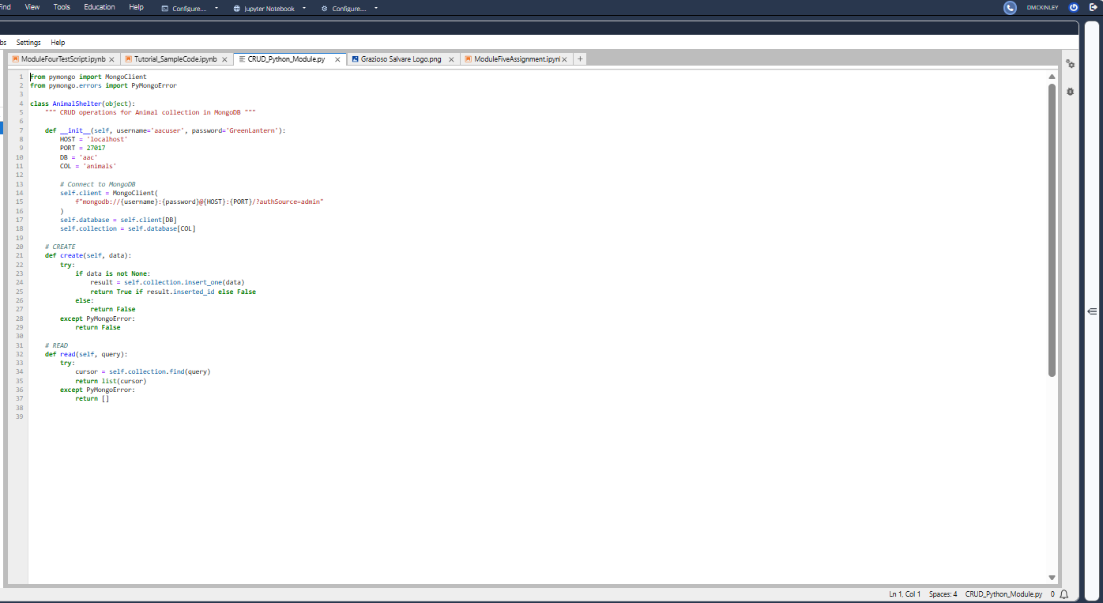

This screenshot shows my ModuleFourTestScript.ipynb running in Jupyter Lab. It includes importing my CRUD module, instantiating the AnimalShelter class with the AAC user credentials, creating a new record for “Duke,” and running a read query for “Labrador Retriever.” The printed output confirms that both the create and read functions worked correctly. 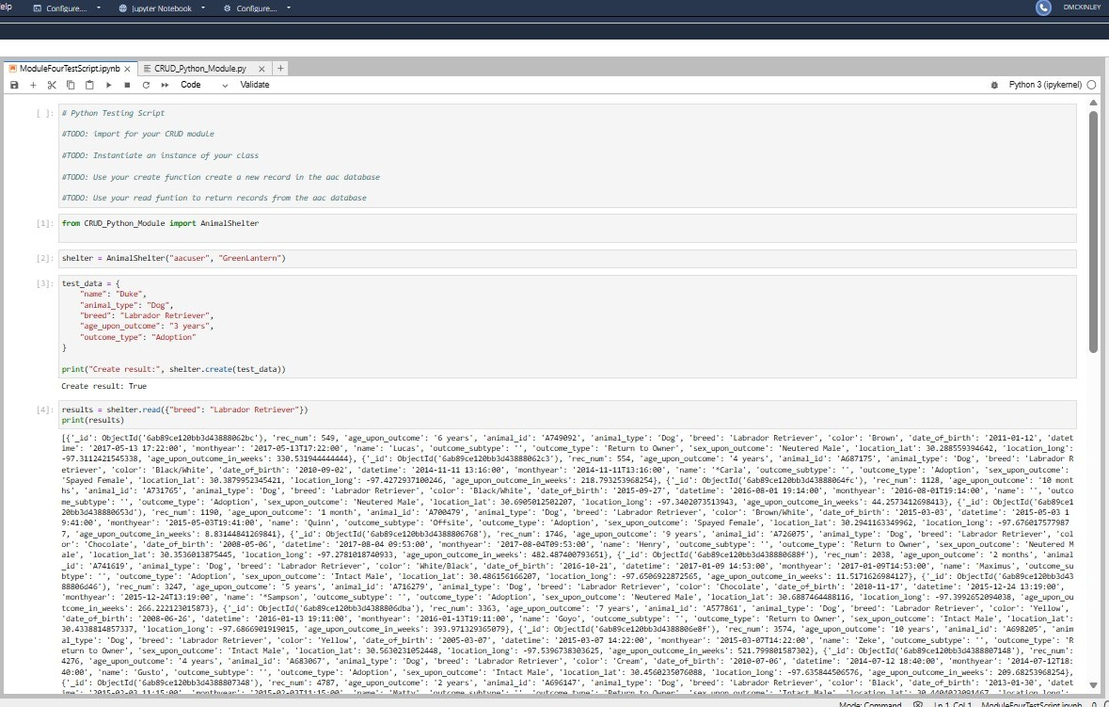

Contact
DeShawn McKinley

